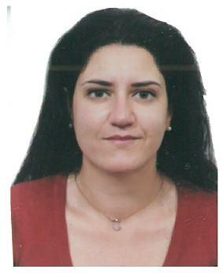
BALA CHRISTINA MIDWIFE
Orth.Crist.Enoseos 45 ,Peristeri , 12134, Athens, Greece
0030 6984585827
balachristie85@gmail.com Linkedin
Christina Bala (researchgate.net)

Education:

University of West Attica, Phd candidate, (2021-present),

Title Thesis: ‘’Study women suffering from primary headache and the usage of medication during the perinatal period’’
University of West Attica , Msc in Advanced and Evidence Based Midwifery Care , Grade 8.08/10, (2016-2019),
Specialization on ultrasounds in midwifery

Technological Institute of Athens, Bsc Midwifery Degree, Grade 7.47/10, (2003-2008)

Academic Experience:

Academic Fellow at University of West Attica , (2020- present), www.midw.uniwa.gr Clinical Tutor at Metropolitan College , (2018- present), www.mitropolitiko.edu.gr

Work Experience:

2019-present: Midwife at Spiti Thilasmou, www.spitithilasou.gr 2019- present : Midwife at medical mobile unit , www.mmu.gr 2016-2017 : Midwife at Medical Centre, www.medihall.gr 2009-2015: Midwife staff at Mitera Hospital, www.mitera.gr
2008-2018: Midwife at obstetrician-gynecologist private practice.

Publications:

‘’The effectiveness of cervical cerclage in perinatal outcome’’, Archives of Hellenic Medicine 2021, 38(6):853–854

Books:

Family Planning Sexual education, V.Vivilaki , Broken Hill Publishers LTD 2021, Chapter 14: Women centered abortion care

Qualifications:
Pilot ultrasound programme 25 hours(2007) Newborn Life Support(NLS) 2013
2nd postgraduate normal childbirth seminar 35 hours(2014) Breastfeeding seminar 10 hours(2010)-35 hours(2015)
Electronic monitoring (cardiotocography) fetus during pregnancy and childbirth 30 hours(2015)

Languages:

English C2 (ECPE) French B2 (DELF)
Basic knowledge Swedish and Greek Sign Language

Computer skills : ECDL CORE (2006) , SPSS

Other skills:

‘Training of adults ‘ National Kapodistrian University of Athens (2016-2017) ‘Organization of events’ seminar(2013)

Driving License : A and B

Personal interests: sailing, scuba diving, dance, reading

